An Inconvenient Sequel- Truth to Power
- Please leave off the question and just put the answer (but make sure to include the question number).
- Answer in complete sentences.
- Use line breaks between answers.
- You do not need to reference your answer. However, make sure to put answer in your own words.
Here are some added notes…..

As you will see in this film, the estimates made 10 years ago in An Inconvenient Truth (2006) were underestimates.

The Earth is warming. No one disputes that. More specifically, 97% of scientists believe that humans are the cause of the warming. “Only 97%?”, a skeptic might ask. If you were to get on plane, and the captain announced “We have a 97% chance of crashing”… would you get off that plane?

Note: The senator interviewing Gore in the opening scene is Oklahoma Senator James Inhofe, who despite having no science background, is a well-established global warming conspiracy theorist who has called climate change a hoax.

There is great irony in Gore’s presentations in south Florida and Houston… this was before the historic record-breaking 2017 hurricane season. The 2017 season included three Category 4 landfalls, record flooding with Hurricane Harvey, record Atlantic wind with Hurricane Irma, and 908mb pressure with Hurricane Maria (which devastated Dominica and Puerto Rico).

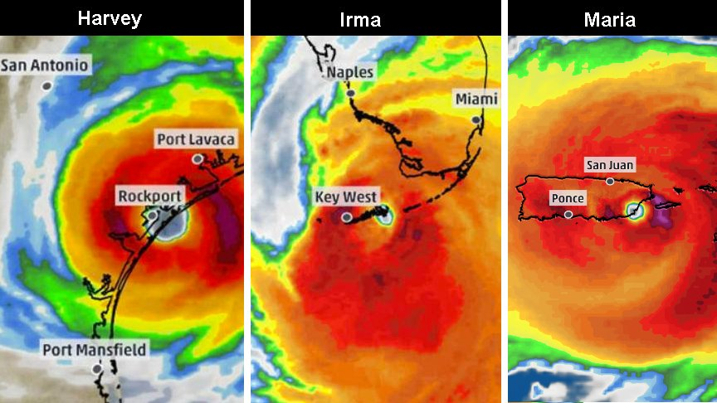

Opinion here… Florida Governor Rick Scott is shamelessly corrupt.

The countries with the world’s largest populations – India and China – play a huge role in climate change. China has made great strides (greater in fact than the US, which is helping drive China’s economy, but the economics are another story). India however is a poorer country, a problem delineated by Christiana Figueres of the United Nations.

There is great irony in listening to Gore speak at the Houston leadership training where he notes that between May 2015 and May 2016, Houston was hit with “two 1-in-500 year floods and one 1-in-1000 year flood.” The irony here is this was before this year’s Hurricane Harvey. Harvey now has the distinction of being the costliest hurricane in the US history (double that of Hurricane Katrina). It is now also the second-costliest natural disaster worldwide (second only to the 2011 Japan earthquake and tsunami). Gore also refers to the flooding in Florida in 2016, again before Hurricane Irma hit the state. 13. How many inches of rain did Hurricane Harvey dump on east Texas, and in how many days?

The implications of climate change go beyond ice melting, sea level rise, ocean warming and hurricanes. Heat is also driving droughts and wildfires. And refugee migrations. Case in point… Syria, which has had the worst drought in 900 years, as far back as records indicate. Moreover, many sociologists - and those that study global politics - believe that the effects of climate change drive global instability and civil wars. That would be a great university course to have (and teach!).

Gore… “What were you thinking??! Why didn’t you listen to the scientists??!” When I teach Natural Disasters on campus, that is the one message I drive home. That is, in the future, your children will ask… “Why didn’t you listen to the scientists??!”

The Paris Agreement… Obama was on board. Trudeau (Canada) on board. Putin (Russia) on board. Merkel (Germany) on board. Jinping (China) on board. Modi (India) conceptually on board.

In sum, the Paris Agreement was a phenomenal success… the fact that so many leaders from so many countries agreed to the provisions and signed. To get India on board, Gore (in my opinion) gets the true “Art of the Deal.”

Georgetown Texas is as “right-wing” politically as you can get. This need not be a partisan issue. Other than climate, it makes economic sense. The main problem (other than people’s ignorance) is Big Oil, as it hurts their profits.

Lastly, as Gore notes earlier in the film, one can choose despair vs hope. Gore chooses hope, with the film ending with him greeting the young generation.

1a. What happened to summer temperatures in the 1980’s?
1b. What then happened to summer temperatures in the 1990’s?
1c. What has happened to summer temperatures from 2005 to now?

2a. What does the green line noted by Dr. Rignot (UC Irvine) represent?
2b. What implications do trends like this have for the world oceans?

3a. In Greenland, Dr. Steffen records the melting of ice from one of the world’s great glaciers. How many meters of ice melted since 2000?
3b. What effect does the water from the melted ice have on the base of glaciers?
3c. Where is all that water going?

4. Internet question… how thick is Earth’s atmosphere?

5. Solar power has been booming. In 2002, the projected solar energy growth predicted for year 2010 was 1 Gigawatt. What was the actual growth by 2010? In 2015?

6. One of the main drivers is the reduced cost of solar silicon solar cells has gone down. What was the cost per watt of solar energy in 1976? In 2015?

7. What was(is) the concern with India in regard to their energy production?

8. What was the significance of the 1972 Blue Marble photo?

9. What was the temperature in Karachi during last year’s heat wave, and how many people died as the result?

10. OK, we know that the Earth’s atmosphere is heating up. But the real problem is the heat that goes into the oceans. How much of the extra heat goes into the oceans?

11. What effect does ocean warming have on hurricanes?

12. Although US cities like Miami, New Orleans, NYC, etc., will be underwater by the time your grandchildren are adults (assuming you are in your 20’s), the US is a rich country and we may - at least partially - mitigate the problem. However, climate change will hit the poorest people the hardest. Looking at Asia alone, what are the populations and elevations above sea level of:

 | Population | Elevation
Mumbai, India
Kolkata, India
Guangzhou, China
Shanghai, China
Ho Chi Minh City, Vietnam
Bangkok, Thailand

14. Name somewhere in the world (besides Syria) where climate change is driving instability.

Internet questions…
15a. How many countries (parties) signed the Paris Agreement?
15b. As of today, what is the one country that has not signed?
15c. What is the only country to have pledged to pull out of the deal?

16. Solar energy has huge potential. Theoretically, one hour of solar energy could power the world’s energy needs - all 7(+) billion people - for how long?

